ORACLE LAB

BCA-DS-552

**Manav Rachna International Institute of Research and Studies School of Computer Applications**

**Department of Computer Applications**

|  |  |
| --- | --- |
| **Submitted By** | |
| **Student Name** | **Rohit Majumder** |
| **Roll No** | **22/FCA/BCA(AIML)/042** |
| **Programme** | **Bachelor of Computer Applications** |
| **Semester** | **5th Semester** |
| **Section** | **D** |
| **Department** | **Computer Applications** |
| **Batch** | **2022-25** |
|  | |
| **Submitted To** | |
| **Faculty Name** | **Mrs. Neerja Negi** |

|  |  |
| --- | --- |
|  | **SCHOOL OF COMPUTER APPLICATIONS** |

**EXERCISE 1**

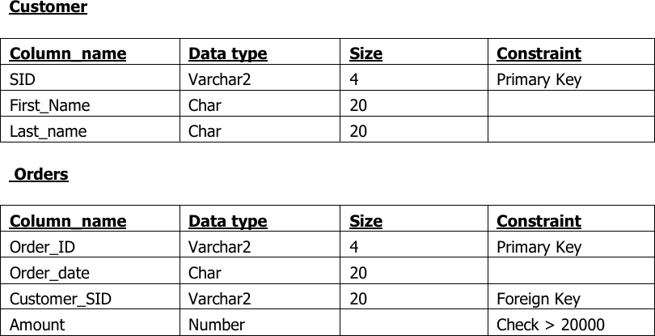**AIM**: Create the following table.

**Output:**

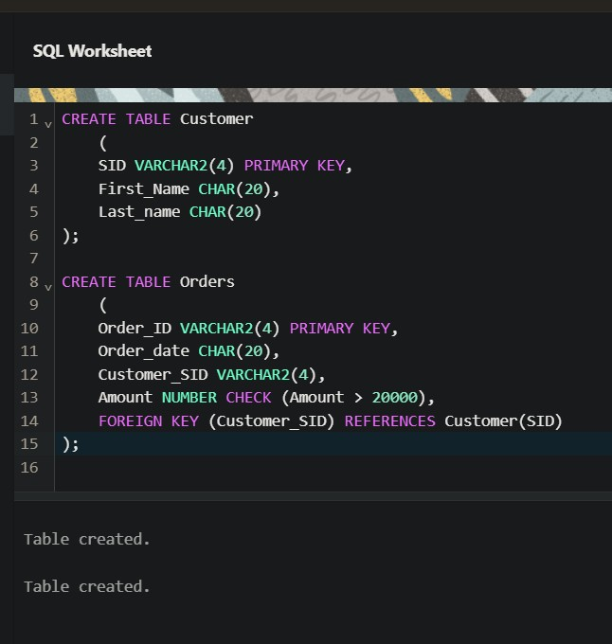

**EXERCISE 2**

**AIM:** Insert 5 records for each table.

**Output:**

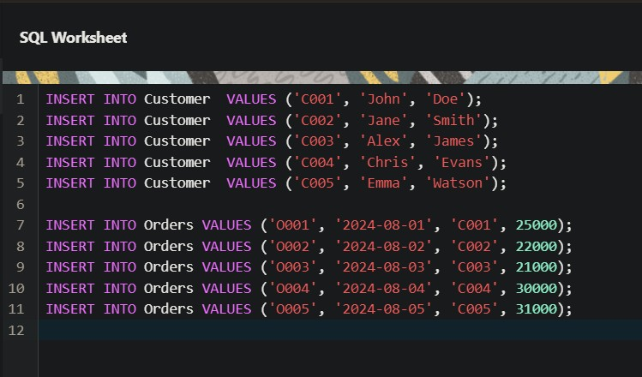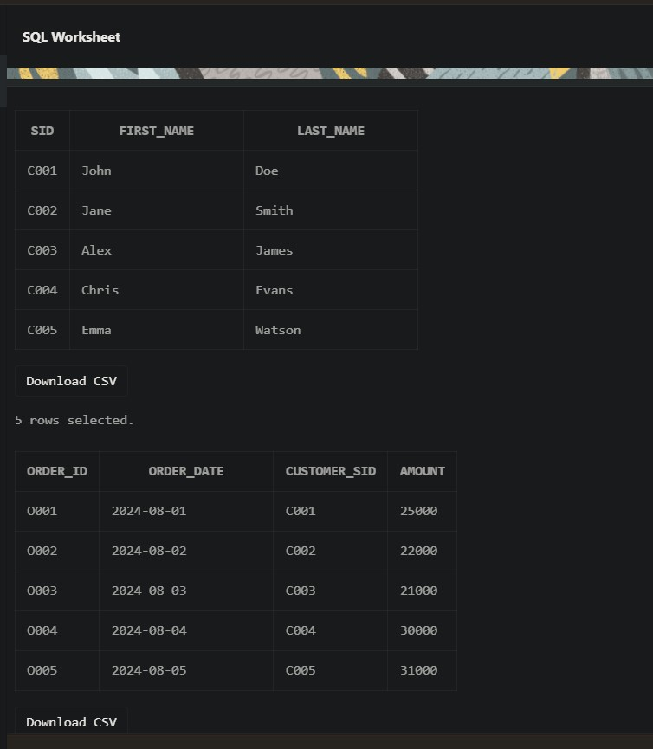

**EXERCISE 3**

**AIM:** Customer SID column in the ORDERS table is a foreign key pointing to the SID column in the CUSTOMER table.

**Output:**

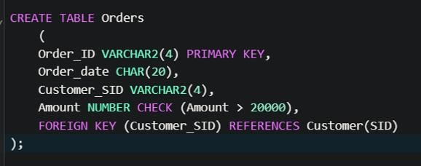

**EXERCISE 4**

**AIM:** List the details of the customers along with the amount.

**Output:**

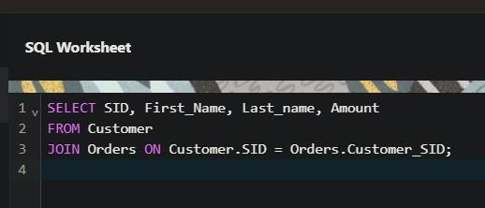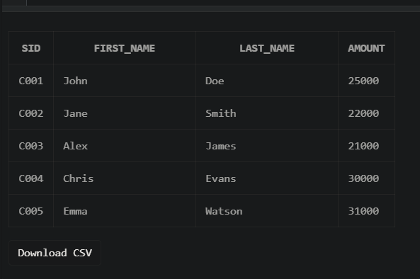

**EXERCISE 5**

**AIM:** List the customers whose names end with “s”.

**Output:**

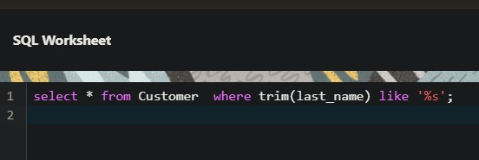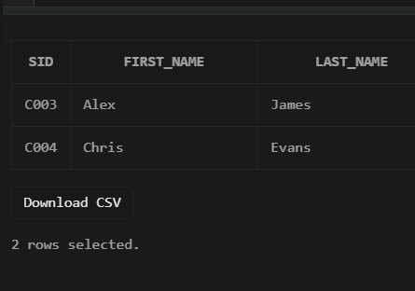

**EXERCISE 6**

**AIM:** List the orders where amount is between 21000 and 30000

**Output:**

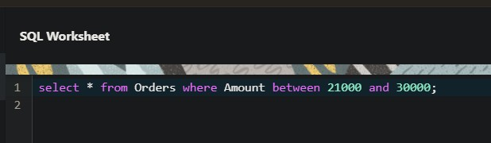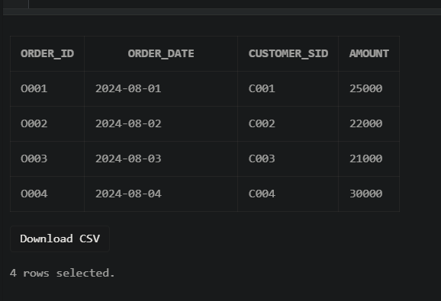

**EXERCISE 7**

**AIM:** List the orders where amount is increased by 500 and replace with name “new amount”**.**

**Output:**

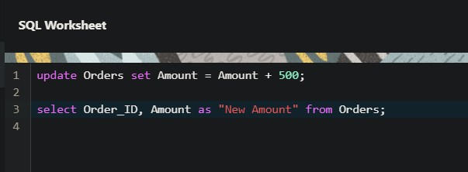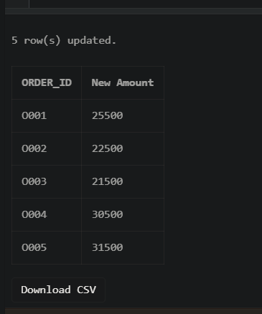

**EXERCISE 8**

**AIM:** Display the order_id and total amount of orders.

**Output:**

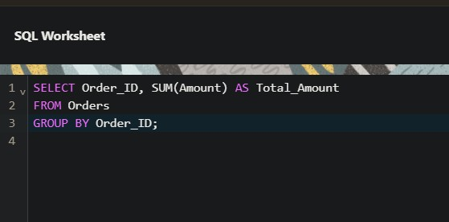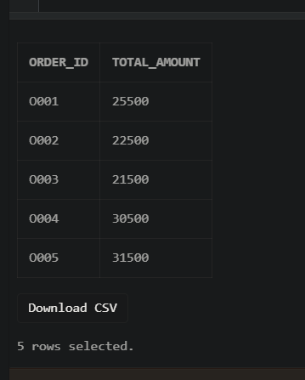

**EXERCISE 9**

**AIM:** Calculate the total amount of orders that has more than 15000.

**Output:**

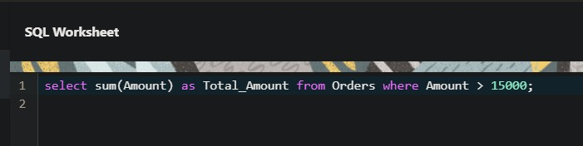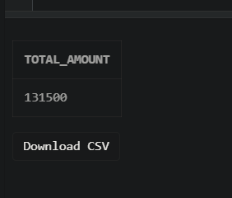

**EXERCISE 10**

**AIM:** Display all the string functions used in SQL.

**Output:**

SELECT

LOWER('ORACLE') AS "Lowercase", -- Converts string to lowercase UPPER('oracle') AS "Uppercase", -- Converts string to uppercase SUBSTR('ORACLE', 2, 3) AS "Substring", -- Extracts substring

LENGTH('ORACLE') AS "Length”, -- Returns length of string INSTR('ORACLE', 'A') AS "Position", -- Returns position of a character LPAD('123', 5, '0') AS "Left Padding", -- Pads a string on the left RPAD('123', 5, '0') AS "Right Padding",-- Pads a string on the right TRIM('O' FROM 'ORACLE') AS "Trimmed" -- Trims a specified character

FROM DUAL;

**EXERCISE 11**

**AIM:** Create the following tables.

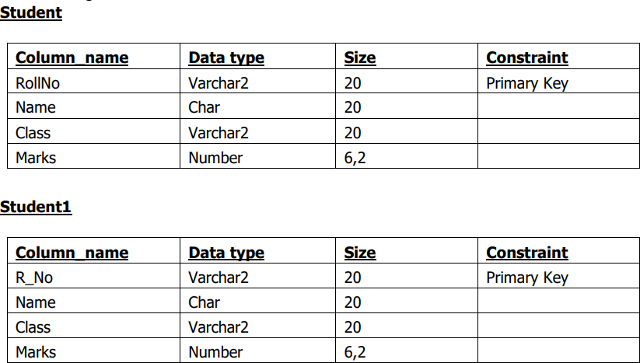

**Output:**

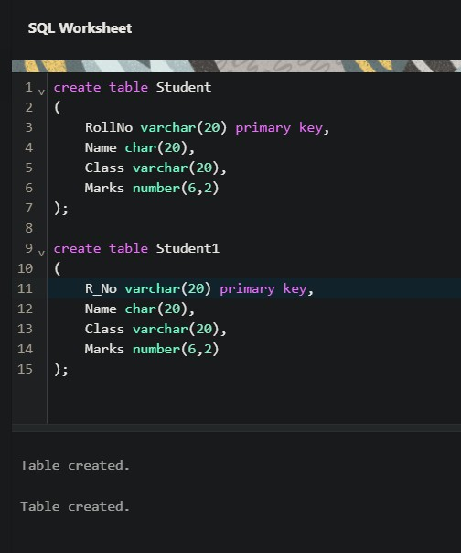

EXERCISE 12

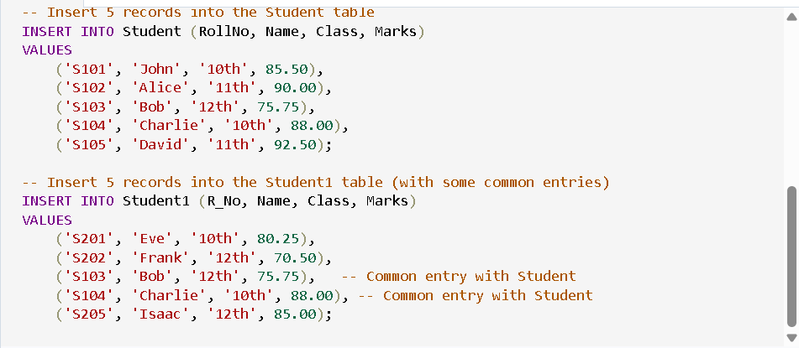AIM: Display all the contents of student and student1 using union clause. First insert 5 records in each table i.e. Student and Student1

Output:

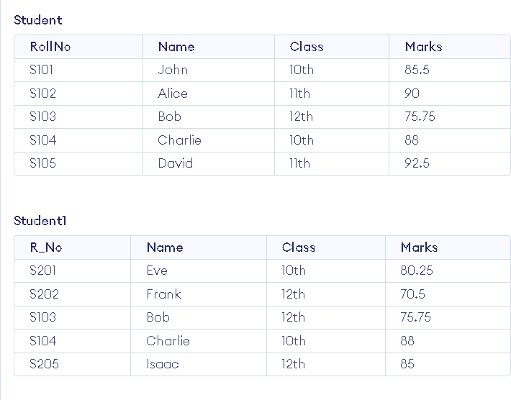

Now union:

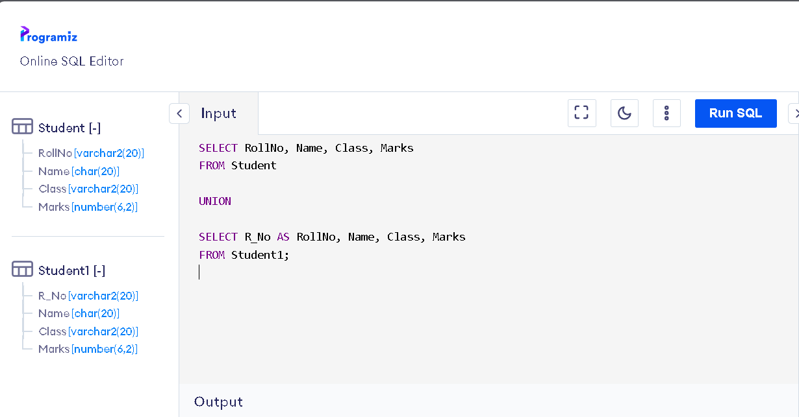

Output:

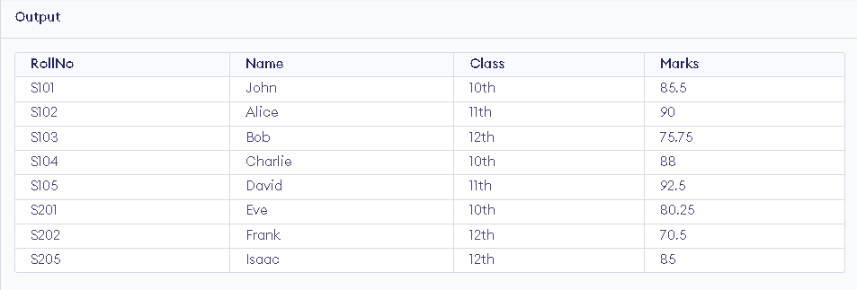

EXERCISE 13

AIM: Find out the intersection of student and student1 tables.

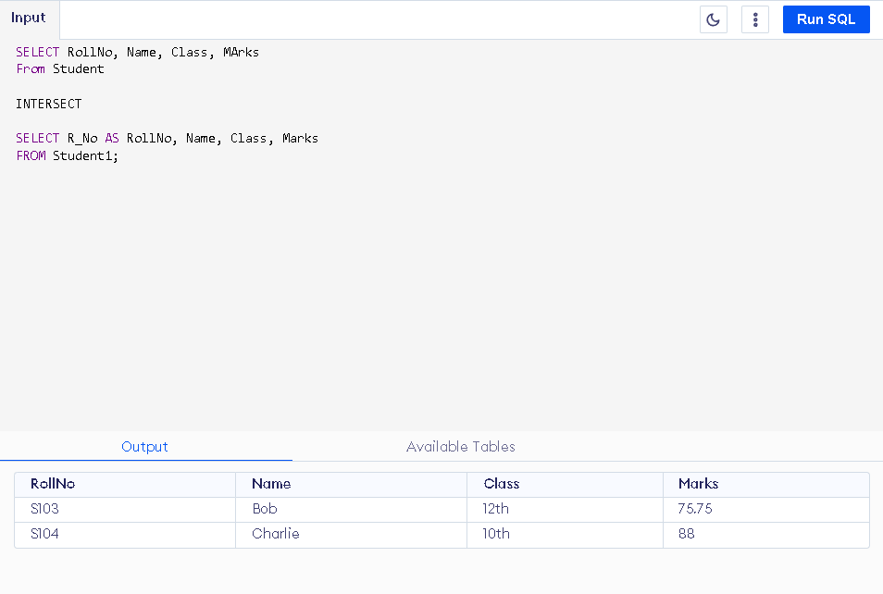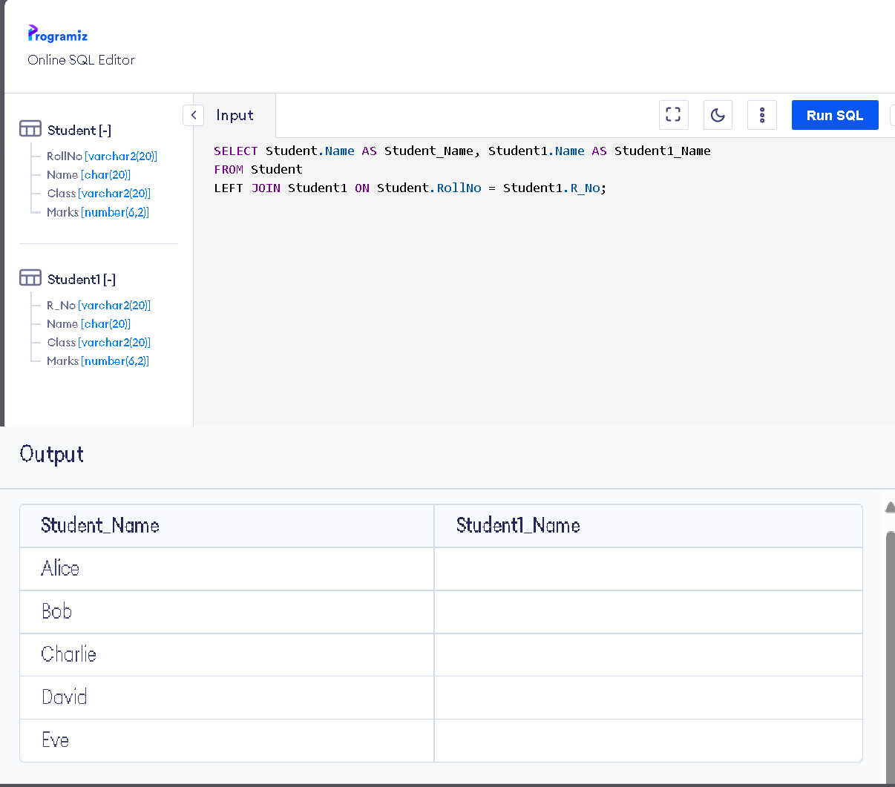

EXERCISE 14

AIM: Display the names of student and student1 tables using left, right, inner and full join. INNER JOIN

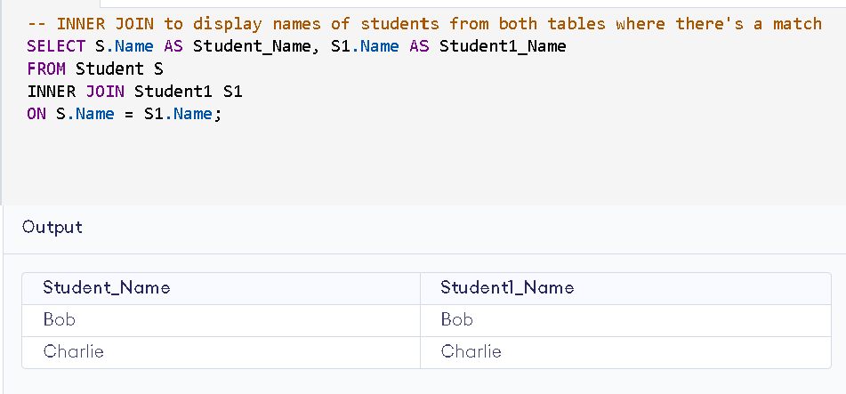

LEFT JOIN AND RIGHT JOIN

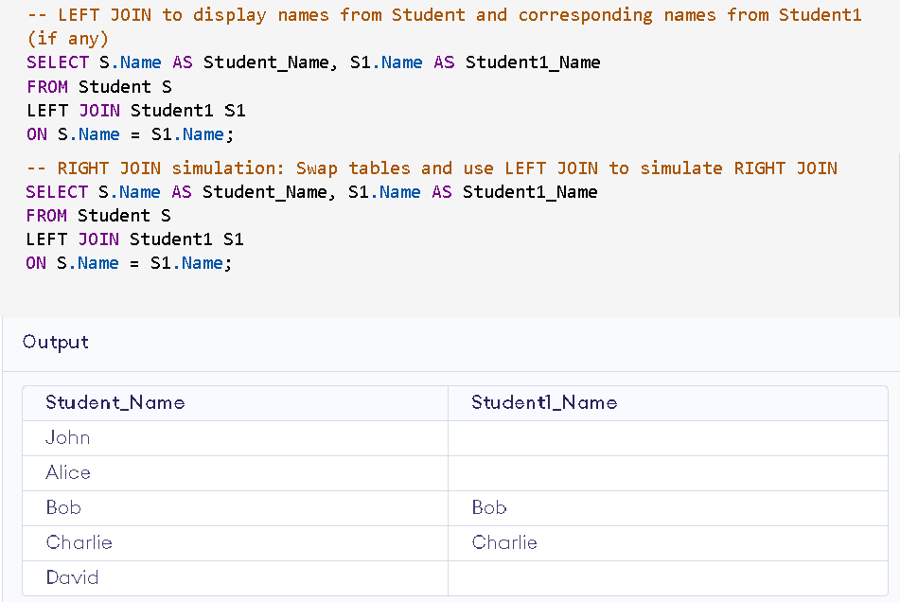

FULL JOIN

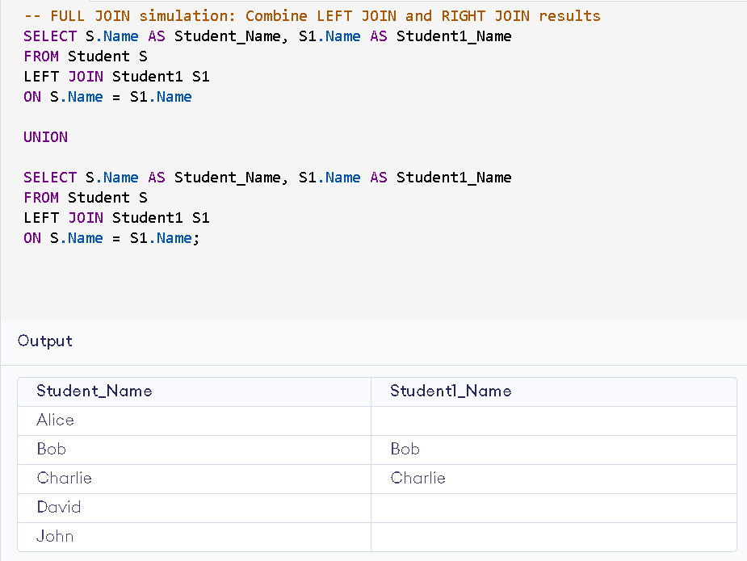

Exercise 15

AIM: To Write a PL/SQL block to calculate total salary of employee having employee number 100.

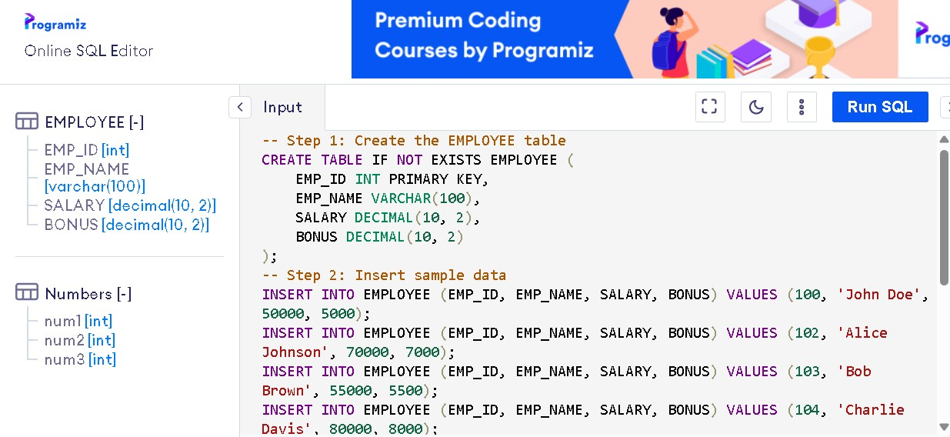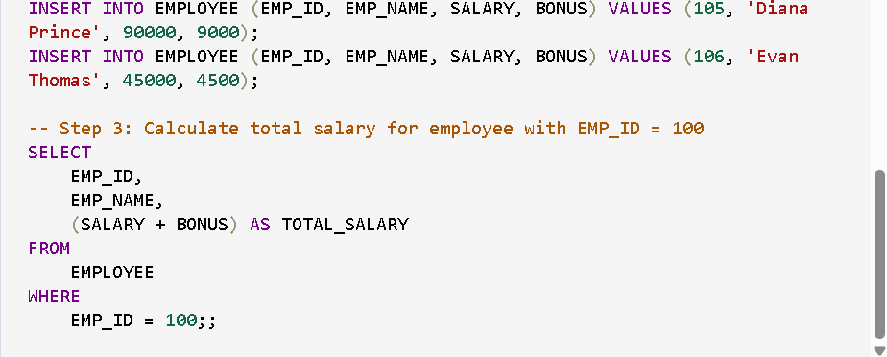

OUTPUT:

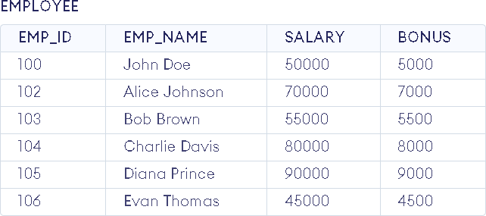

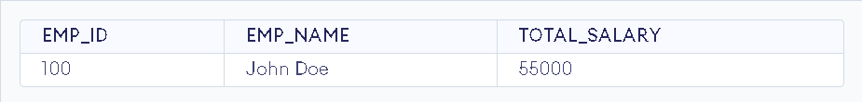

EXERCISE 16

AIM: To Write a PL/SQL code to find the greatest of three numbers.

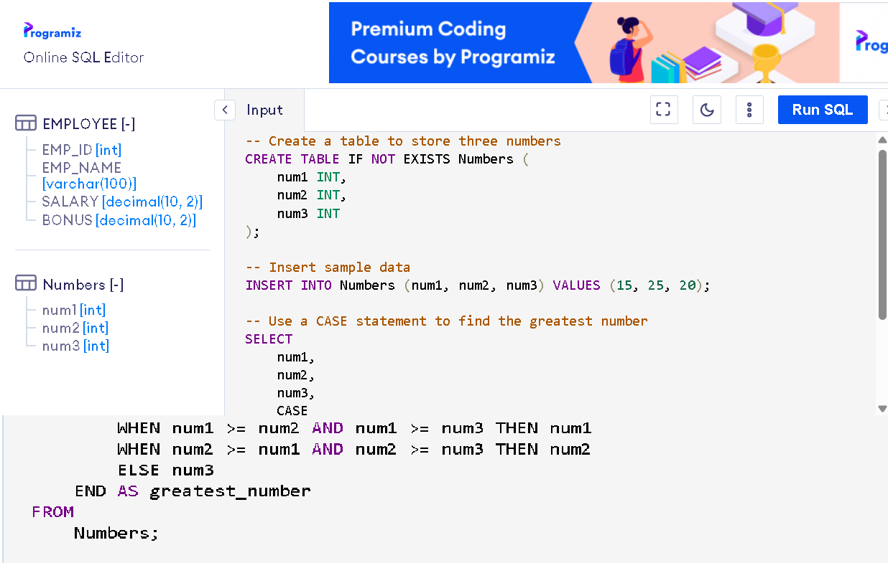

OUTPUT:

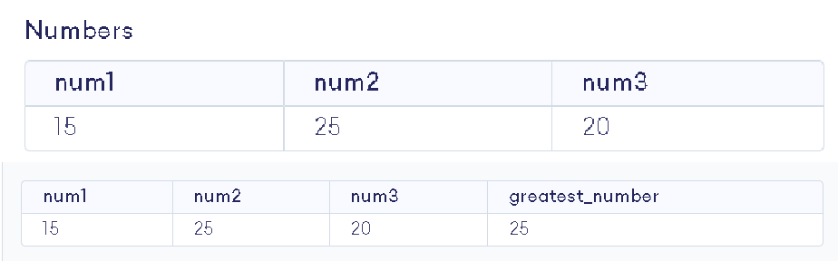

EXERCISE 17

AIM: To Write a PL/SQL code to print the numbers from 1 to n.

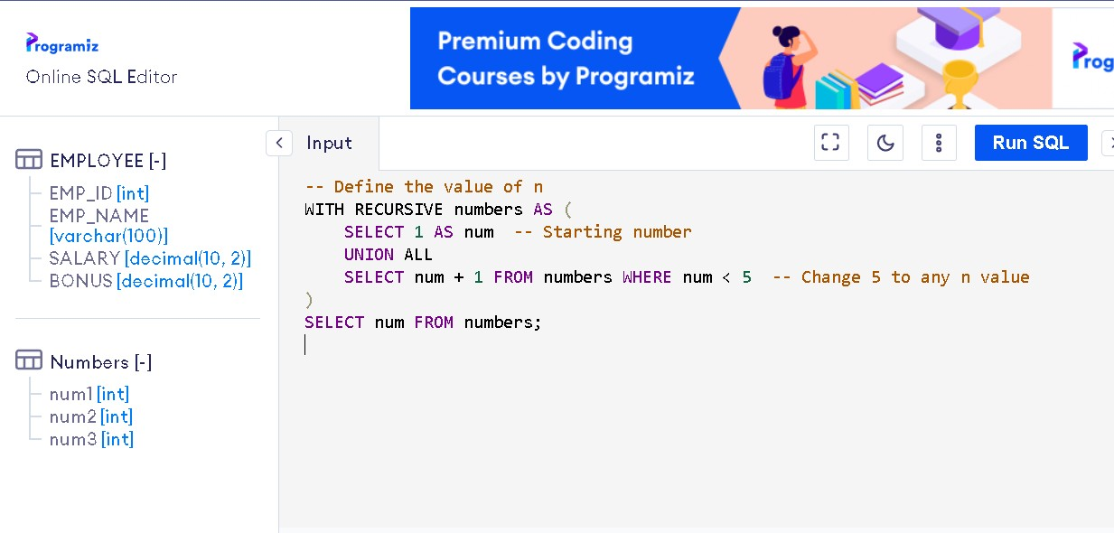

OUTPUT:

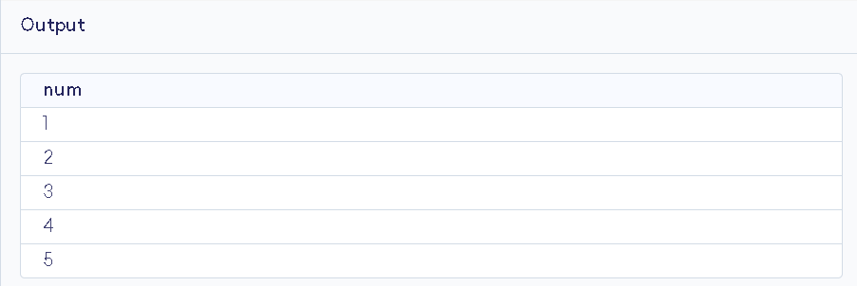

EXERCISE 18

AIM: To Write a PL/SQL code to reverse a string using for loop.

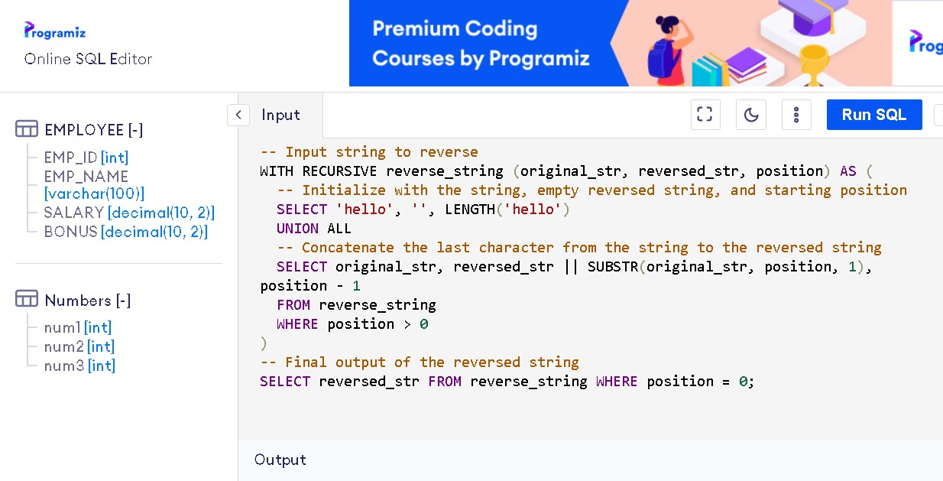

OUTPUT:

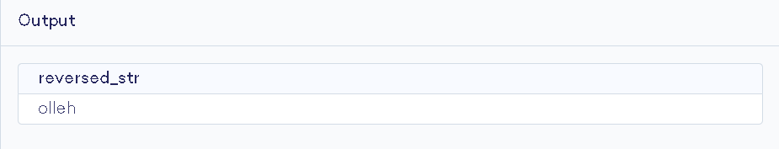

EXERCISE 19

AIM: To Write a PL/SQL code to find the sum of n numbers.

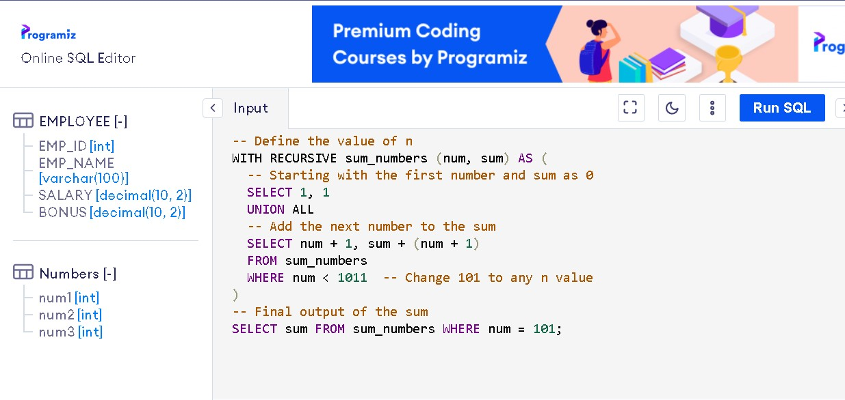

OUTPUT:

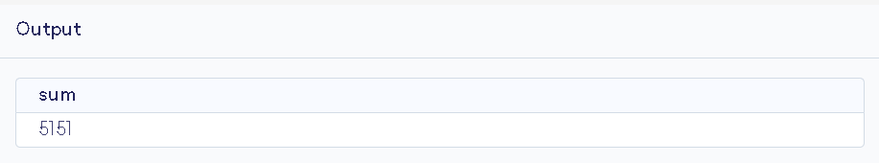

EXERCISE 20

AIM: To Consider a PL/SQL code to display the empno, ename, job of employees of department number 10.

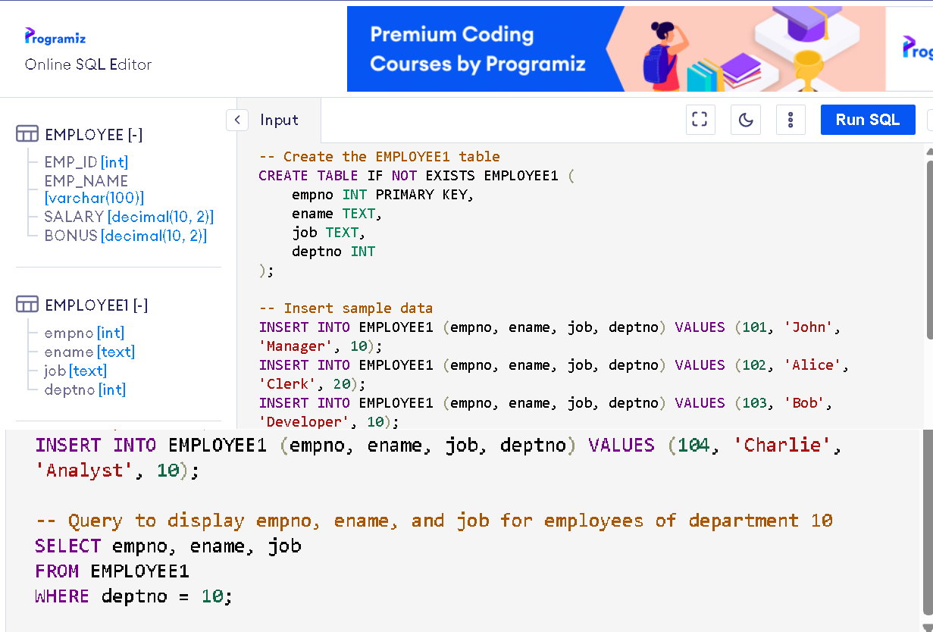

OUTPUT:

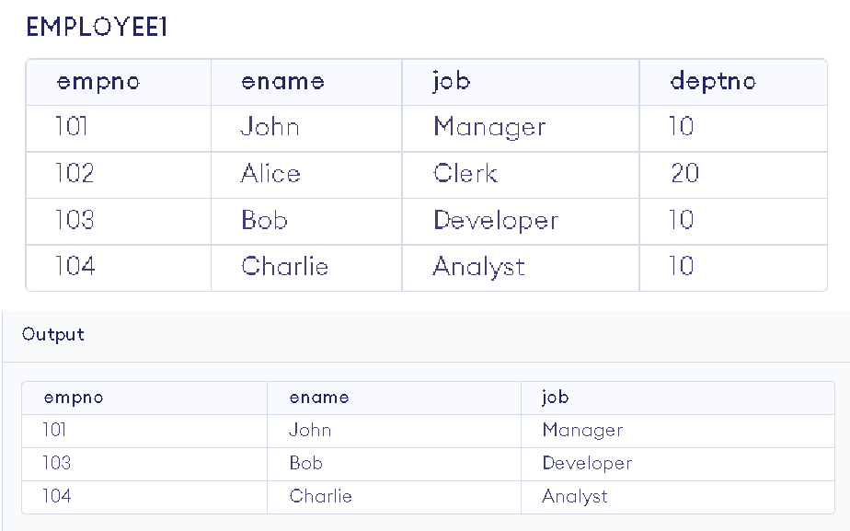

EXERCISE 21

AIM: To Consider a PL/SQL code to display the employee number & name of top five highest paid employees.

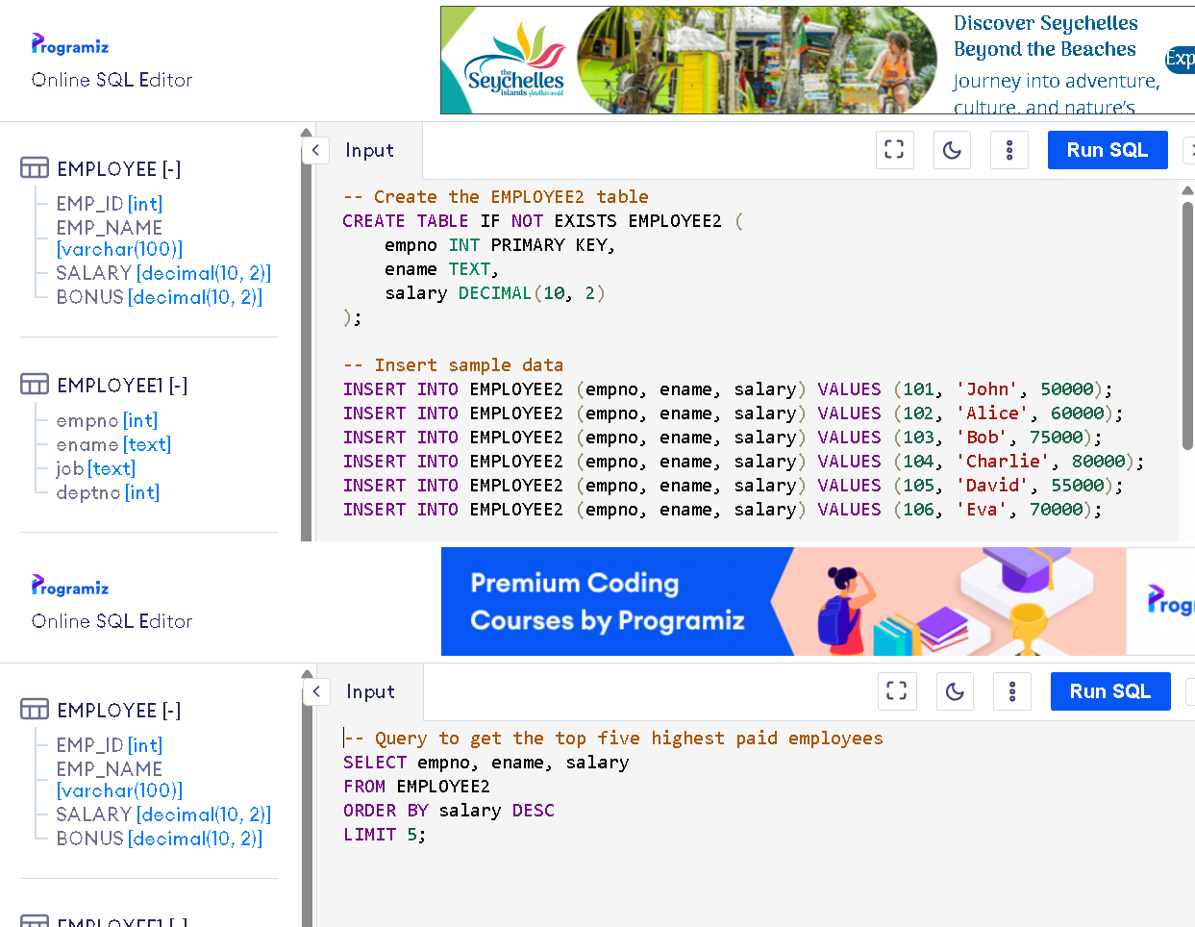

OUTPUT:

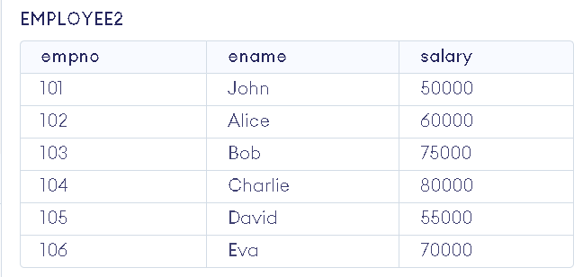

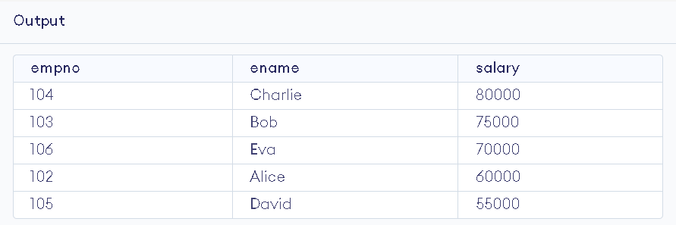

EXERCISE 22

AIM: To Consider a PL/SQL procedure that accepts 2 numbers & return addition, subtraction, multiplication & division of two numbers using stored procedure AND local procedure.

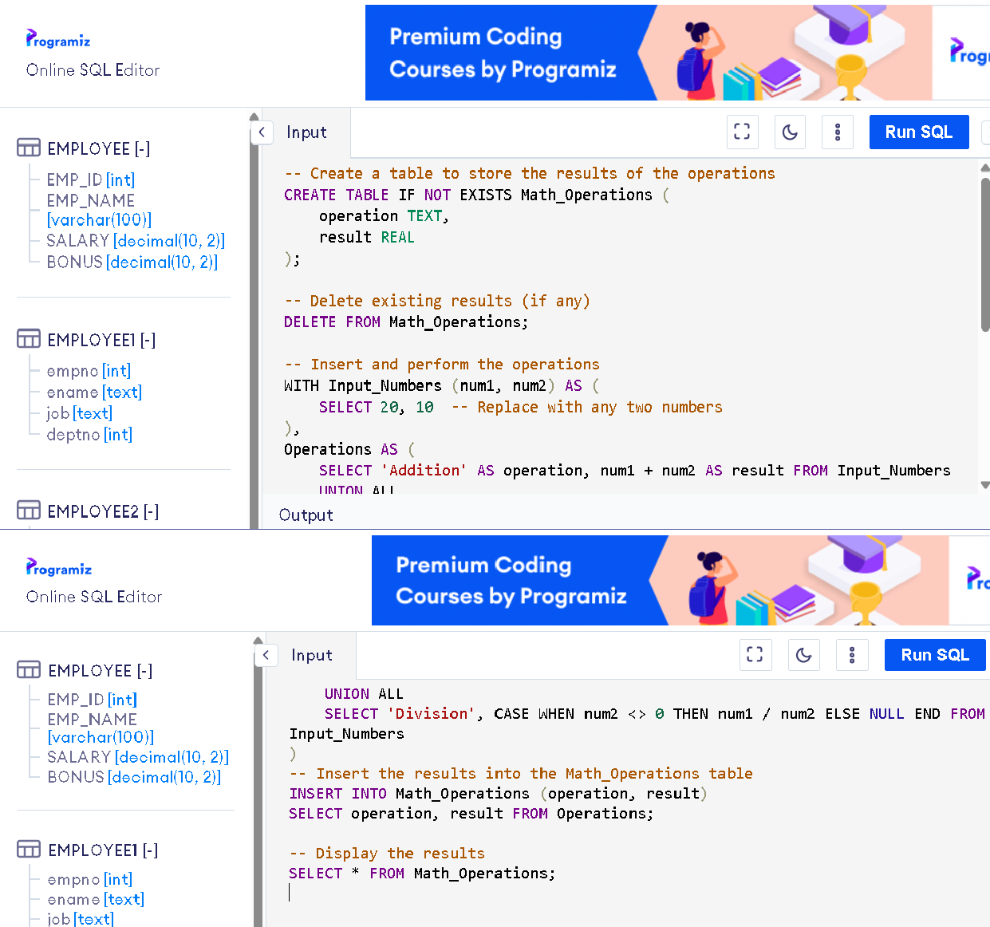

OUTPUT:

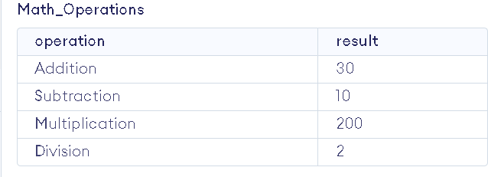

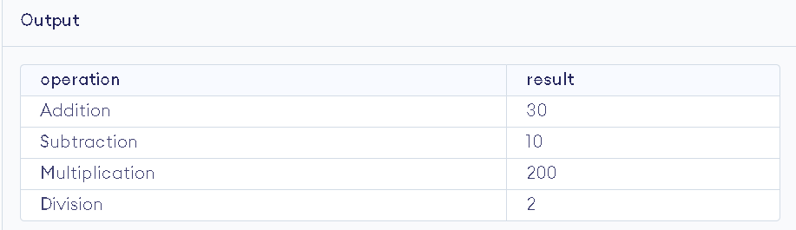

EXERCISE 23

AIM: To Consider a PL/SQL code that accepts 2 numbers & return addition, subtraction, multiplication & division of two numbers using stored functions and local function.

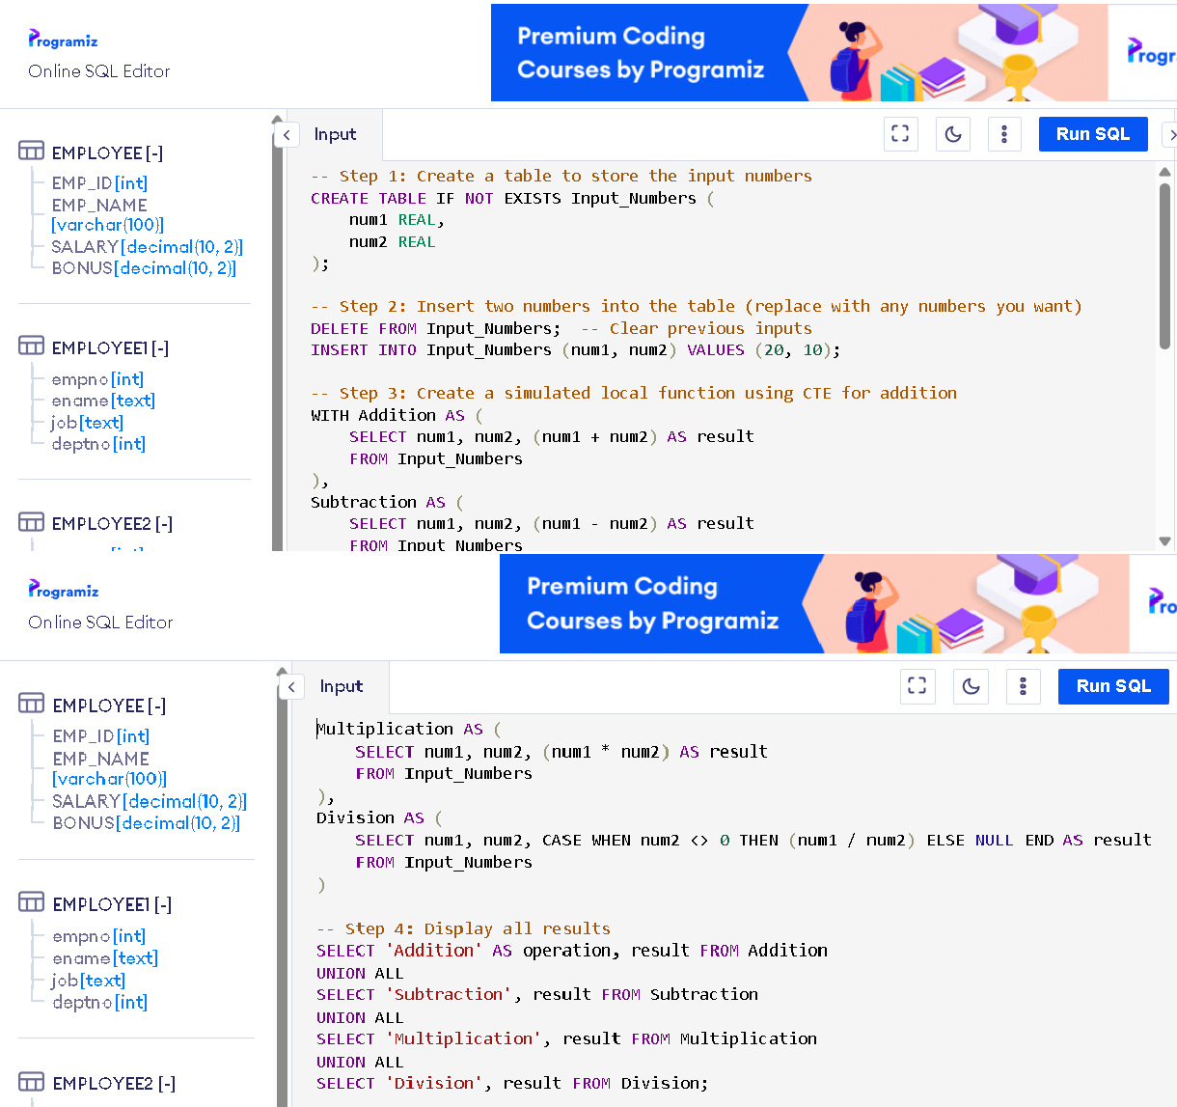

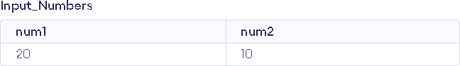OUTPUT:

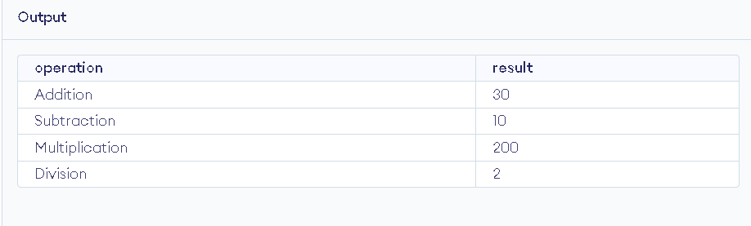

EXERCISE 24

AIM: To Write a PL/SQL block to show the use of NO_DATA FOUND exception.

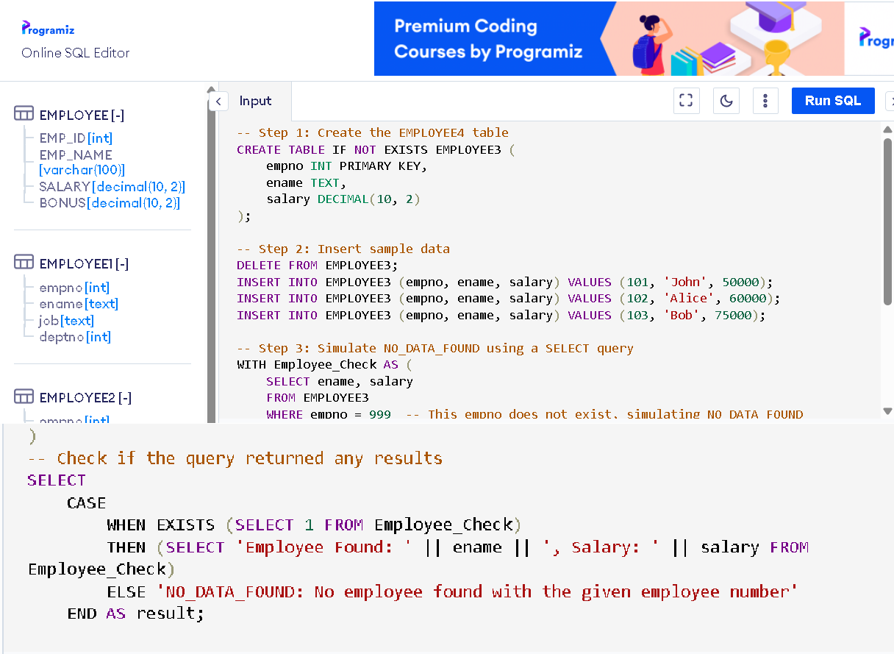

OUTPUT:

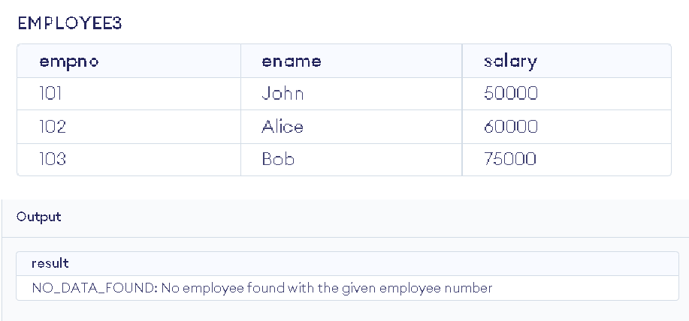

EXERCISE 25

AIM: To Write a PL/SQL block to show the use of TOO_MANY ROWS exception.

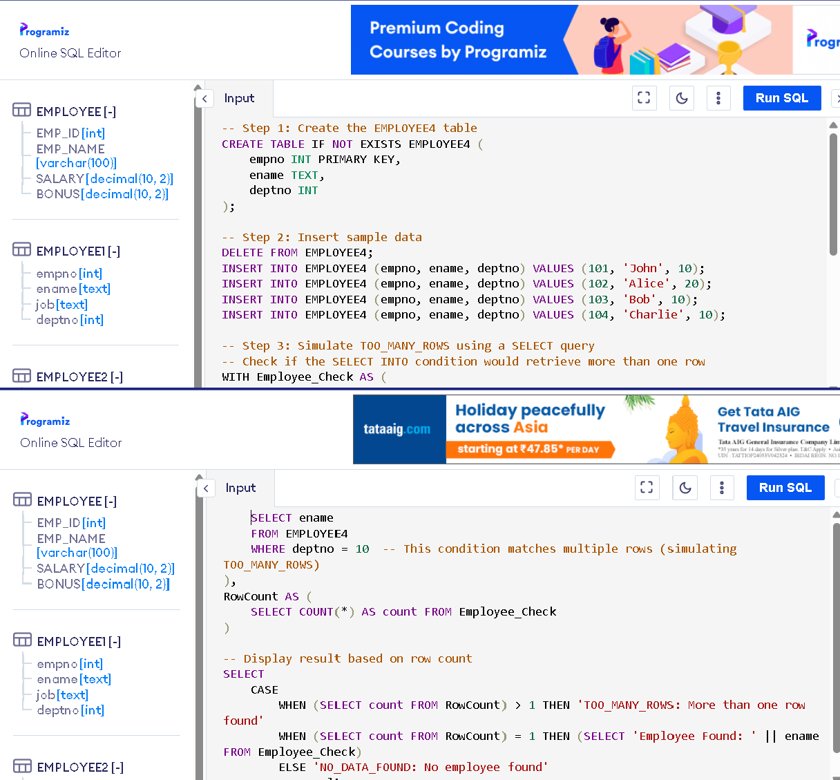

OUTPUT:

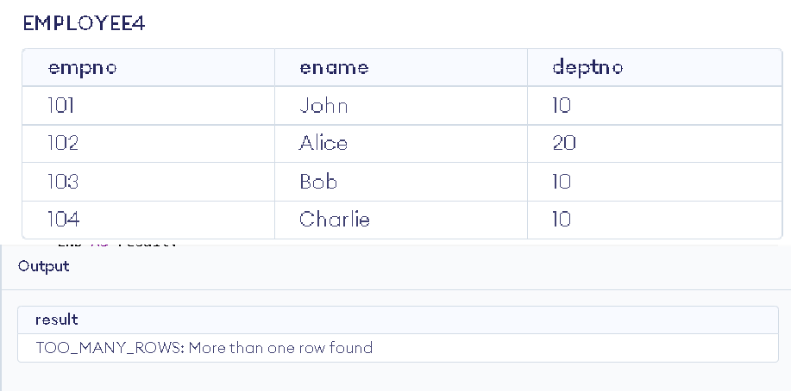

EXERCISE 26

AIM: To Write a PL/SQL block to show the use of ZERO_DIVIDE exception.

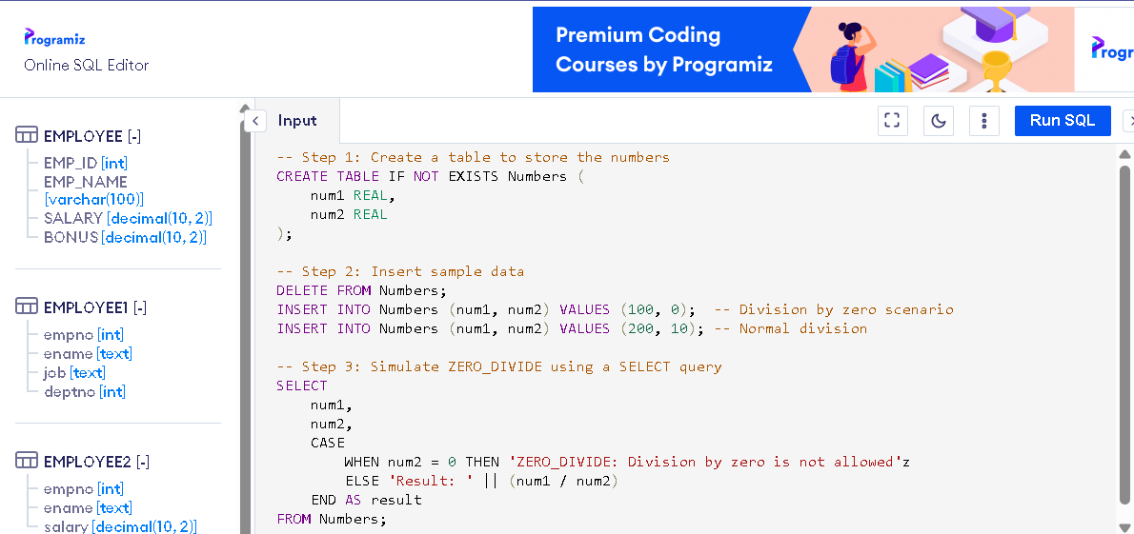

OUTPUT:

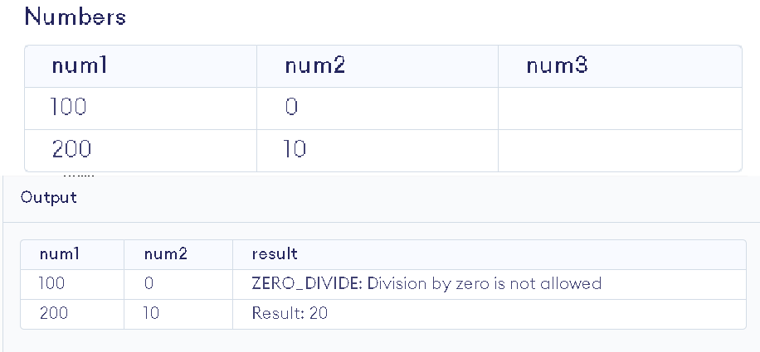

EXERCISE 27

AIM: To create a trigger on the emp table, which store the empno& operation in the table auditor for each operation i.e. Insert, Update & Delete.

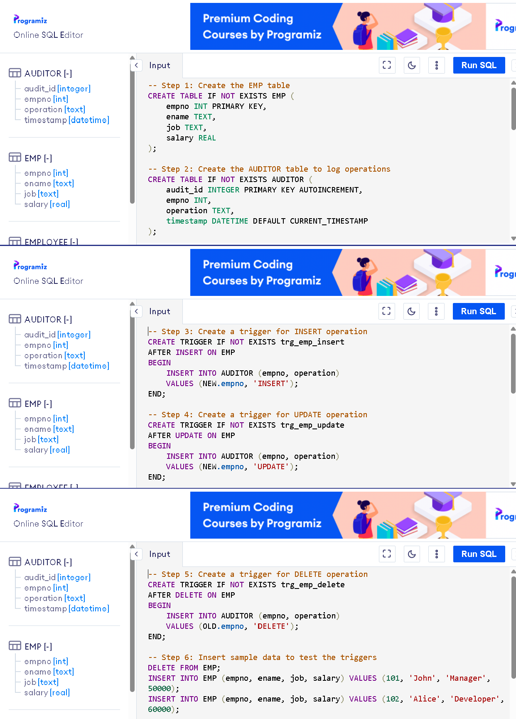

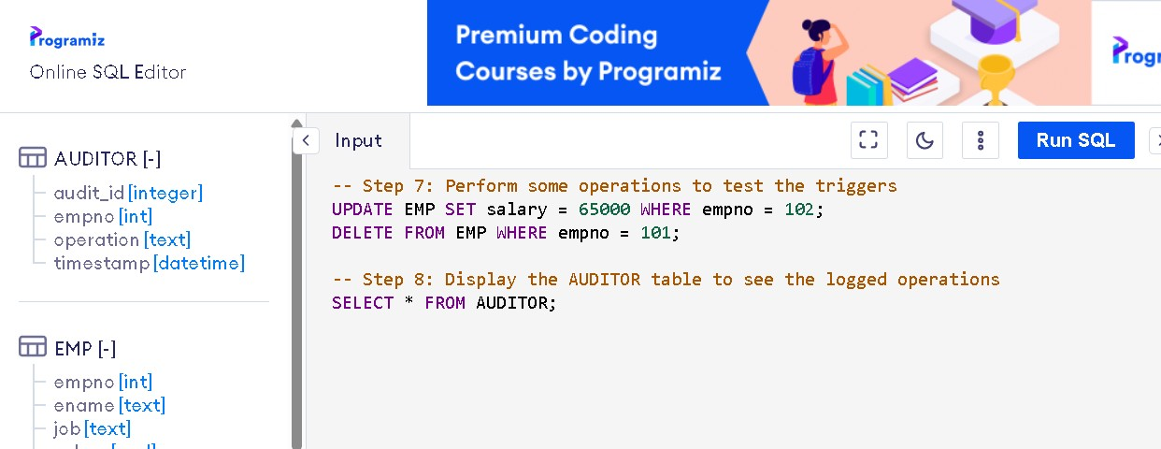

OUTPUT:

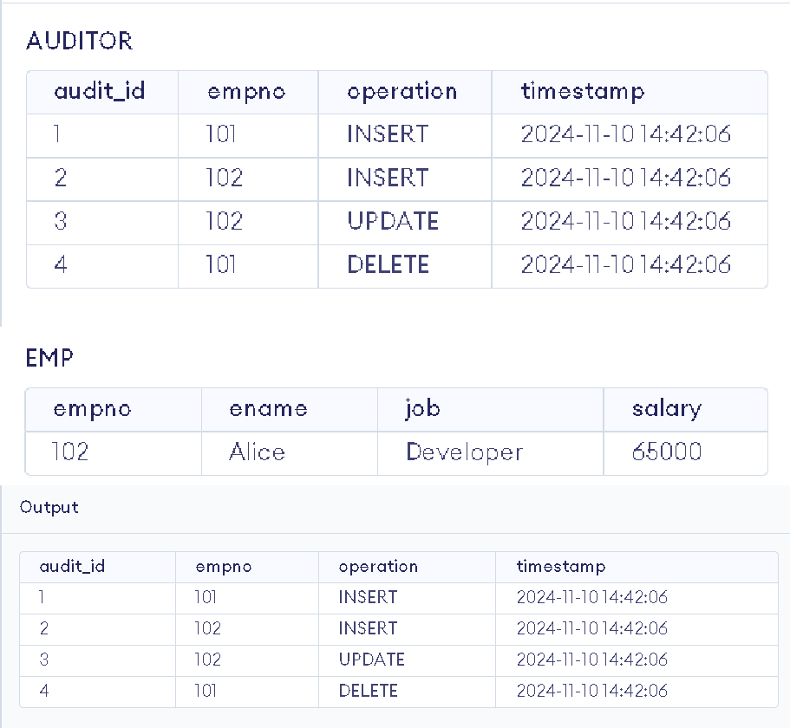

EXERCISE 28

AIM: To create a trigger so that no operation can be performed on emp table.

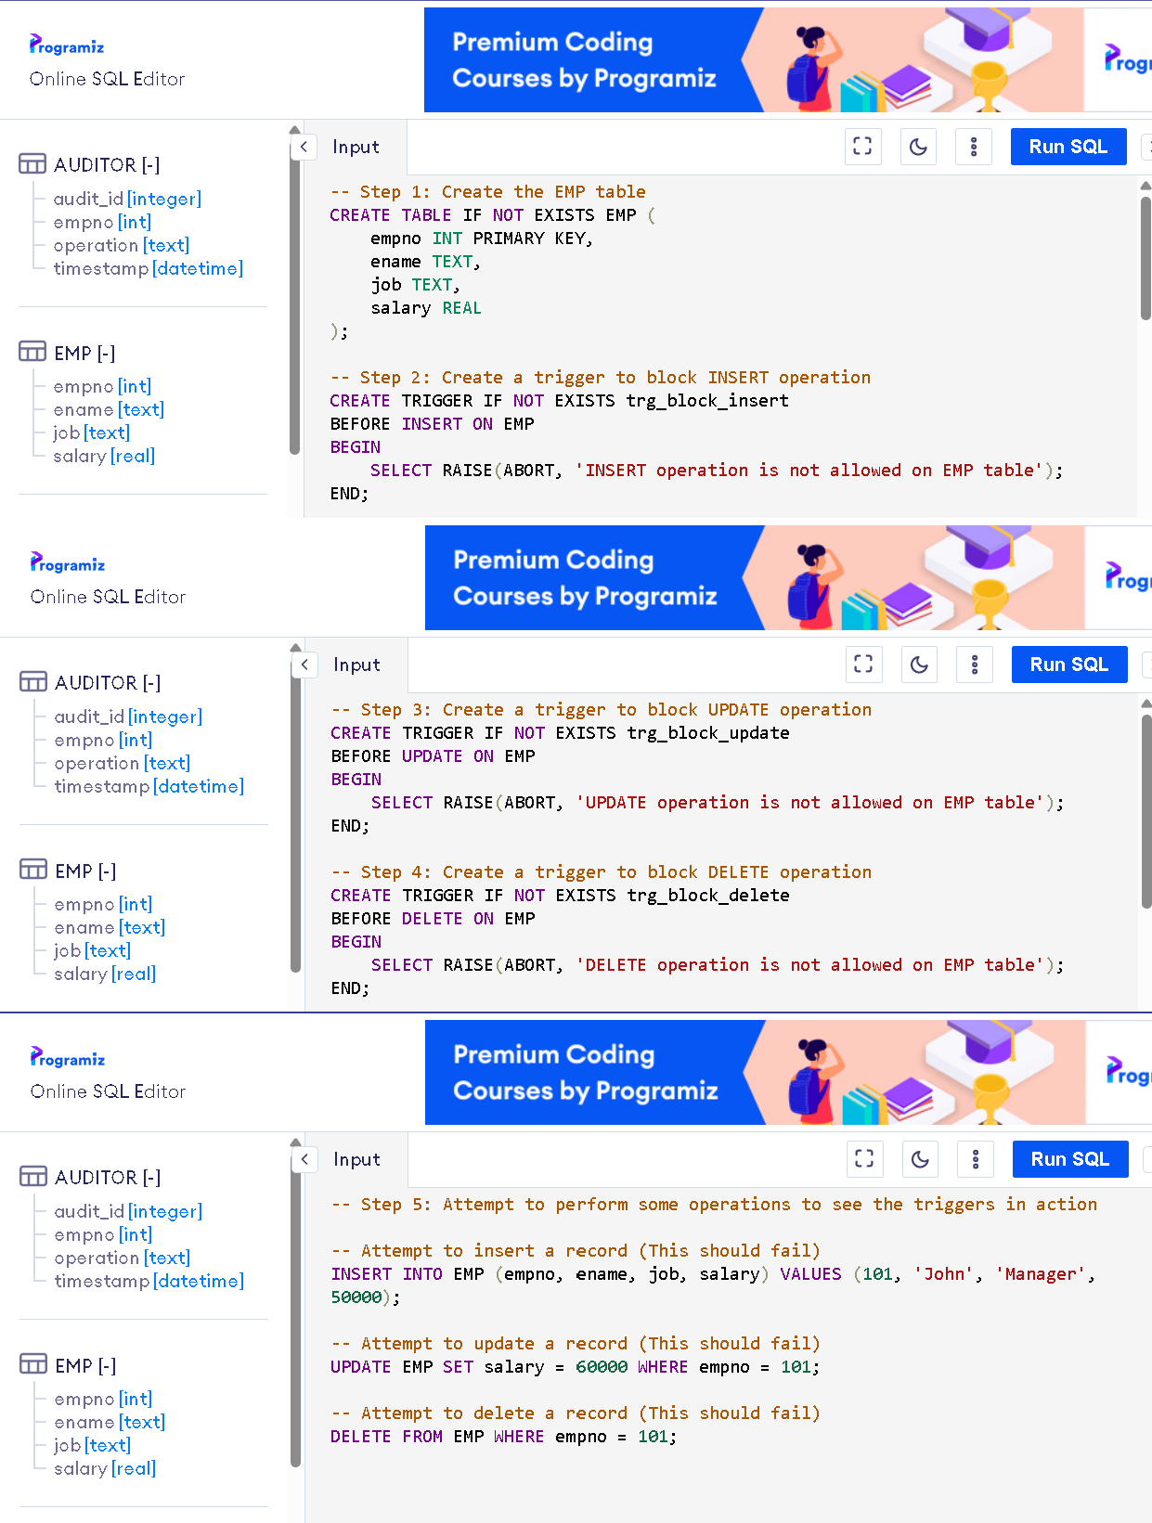

OUTPUT:

